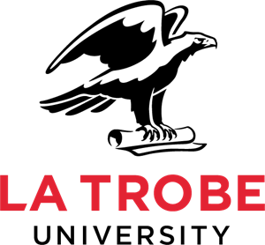
A research study about Radiotherapy and
people who have a Learning Disability and cancer

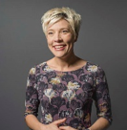 | Hello, my name is Charlotte Nutting  - I am a PhD research student at Sheffield Hallam University (England) and La Trobe University (Australia).  - I am also a registered Learning Disability Nurse and Social Worker.
I am undertaking a research study titled:
- An investigation of the process of Radiotherapy as perceived by people with a Learning Disability who have cancer, their family members, paid carers, and the professionals that support them: A Constructivist Grounded Theory Study’.

The aim of the research study is:
- To explore multiple stakeholder perspectives and processes involved in Radiotherapy decision making, treatment and post-treatment support in England and Australia for people with Learning Disabilities who have cancer.
You may be interested in this research study and want to participate in an interview:
- If you are a family member, paid carer or a healthcare, social care or medical professional who has supported a person who has a Learning Disability and cancer with Radiography.

- You may also support a person with a Learning Disability who has or has had cancer who may be interested in finding out more this research study.
TO FIND OUT MORE:
Look at the study webpages & Participant Information Sheet: https://tinyurl.com/IDandRadio

Watch the short study video:
https://tinyurl.com/RTLDstudy

Contact me by phone or email: 0114 2255989 c.nutting@shu.ac.uk
1

